Categorical variables in datasets like the "Richter's Predictor: Modeling Earthquake Damage" are obfuscated into random lowercase ASCII characters (e.g., 'a', 'r', 'v') for privacy. Because the same character can represent different original values across columns, you must treat these as unique labels within each column
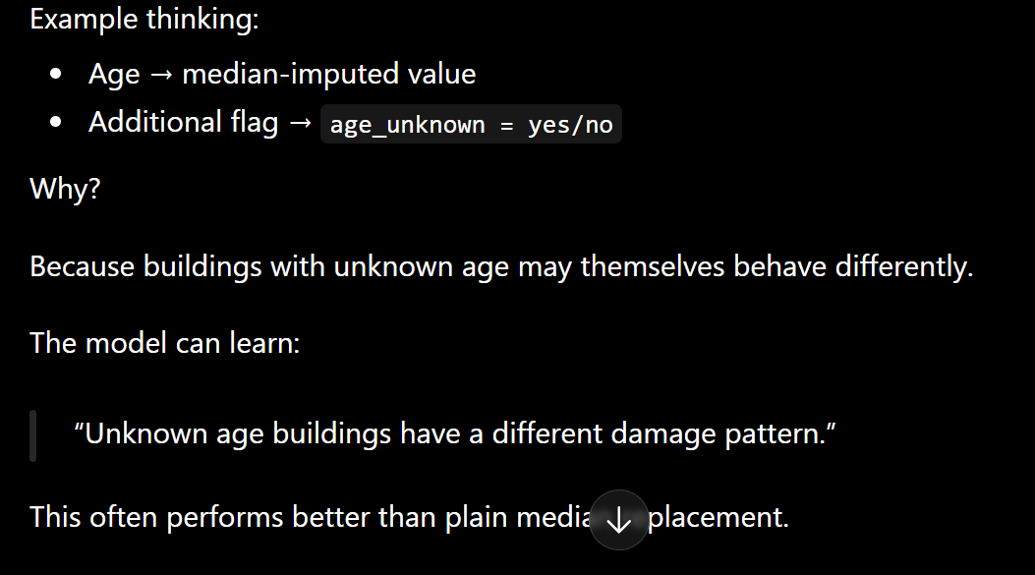

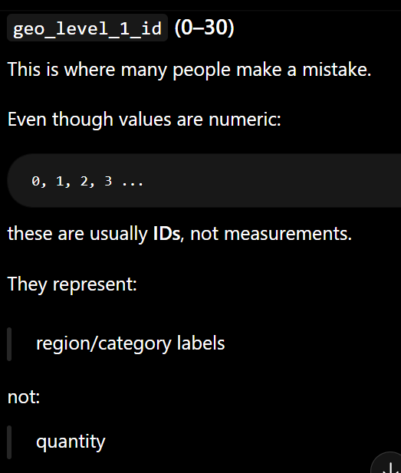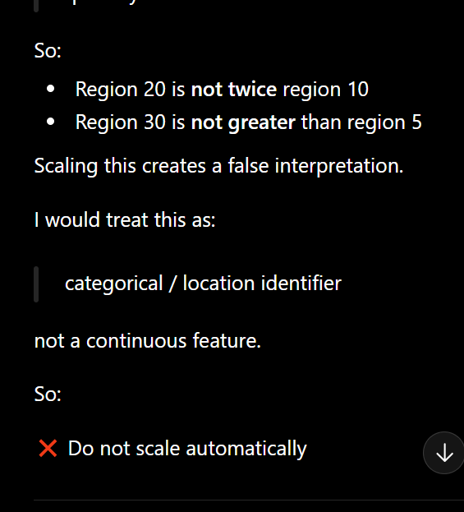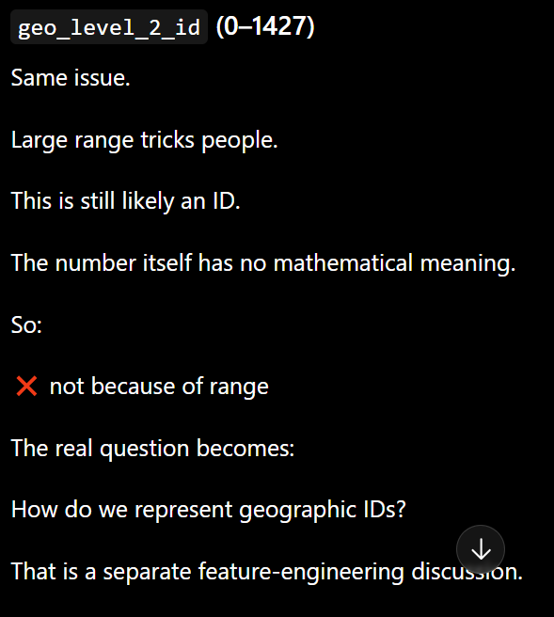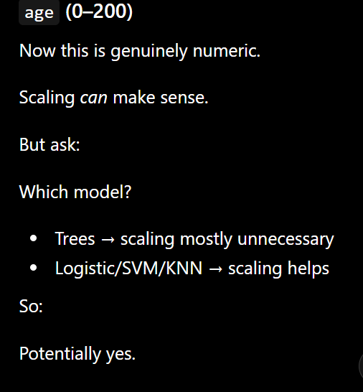

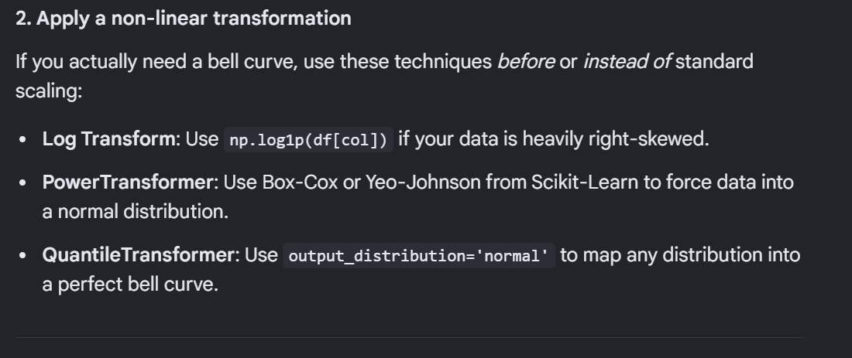
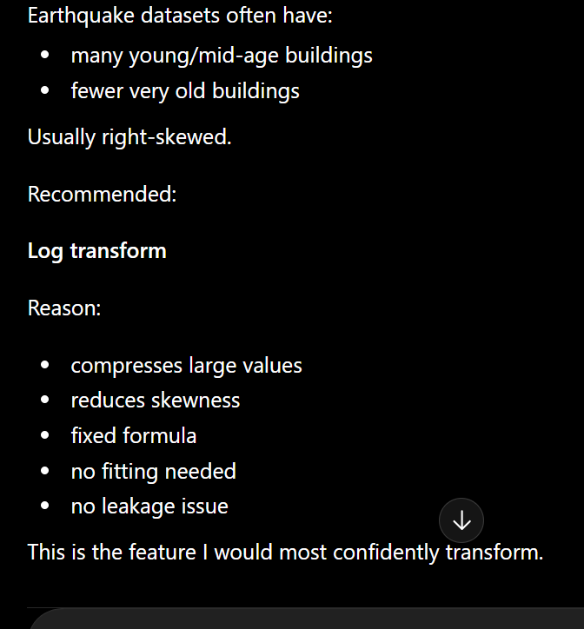 for the age of the building
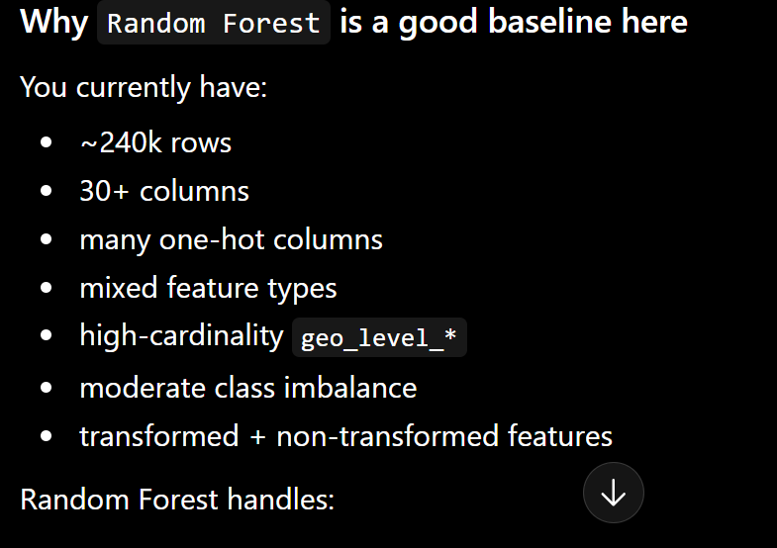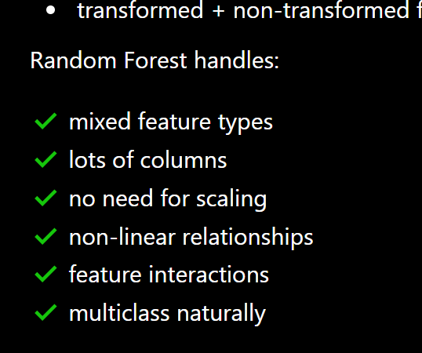

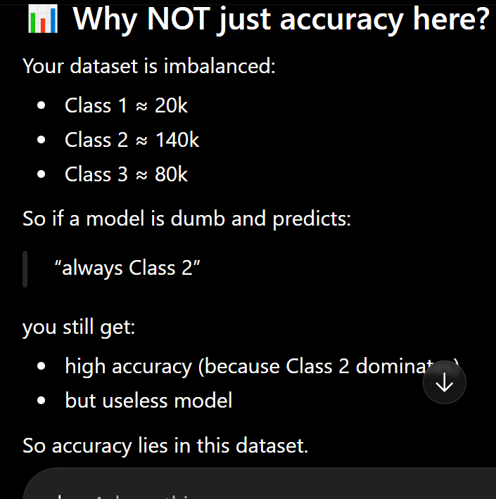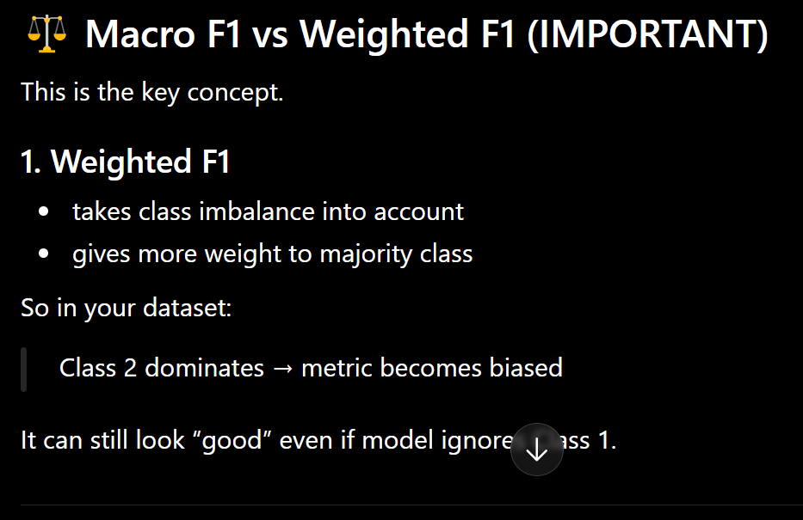
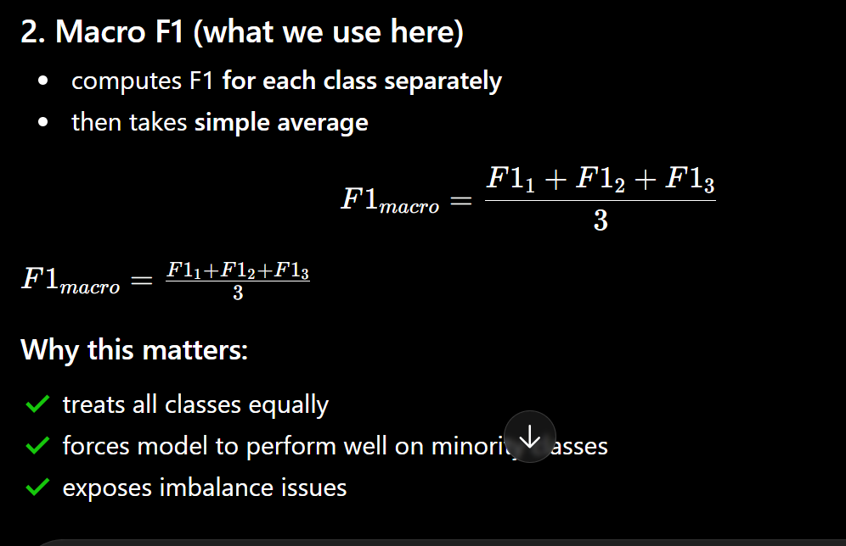
For random forest:
Your weighted F1 = 0.64 and macro F1 = 0.62 are fairly close.
That means class imbalance is affecting performance, but not catastrophically. If macro had dropped much lower (for example 0.45), I’d be more worried about minority class neglect.
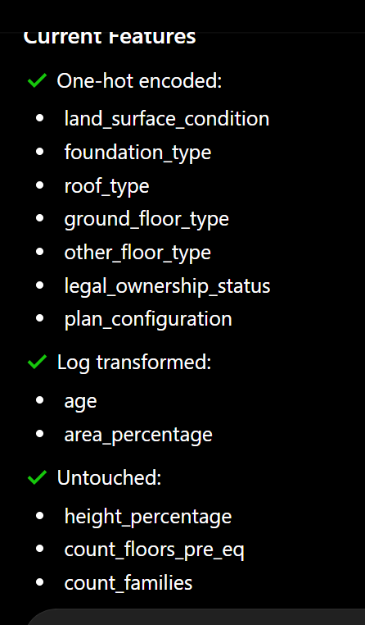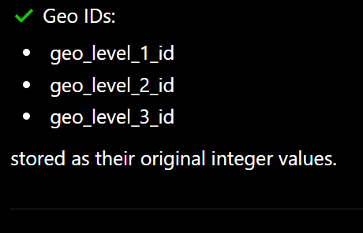

Step 3: Train LightGBM
- Use a sensible baseline configuration
- Not the default parameters
- Not heavy tuning yet
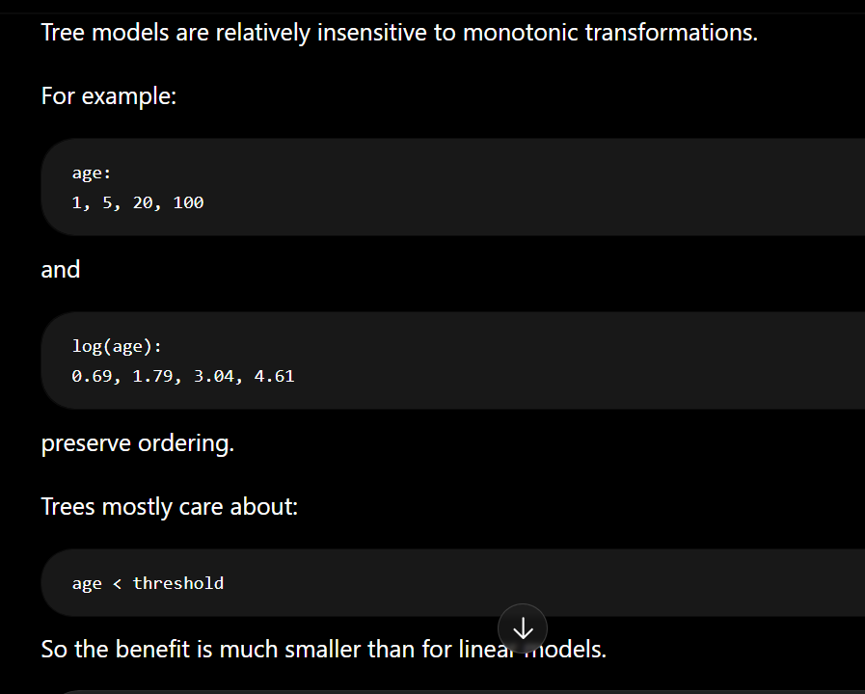

If frequency encoding performs better
Keep it.
You have a stronger feature representation.

If raw IDs perform better
Keep raw IDs.
You now have evidence that LightGBM extracts useful structure directly.

